Careers4Terps Registration

Thank you for your interest in recruiting at UMD!
The first place to start for all employers is our jobs/internship portal, Careers 4 Terps (https://umd-csm.symplicity.com/employers). Please be mindful of our employer recruiting guidelines, which can be found here

To register, click either “Sign up” or “Sign up and post job”

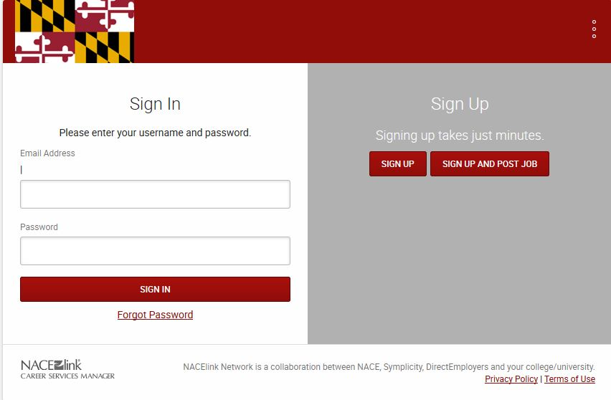
Choose either option

Once you select an option, please fill out as many details as you can. The boxes with the red stars next to them (see screenshot that follows) MUST be completed in order for you to register and/or post a job successfully.

In the screenshot, although the description field is not marked with the star, the more information you can give students, the better the levels of interest in positions you post is likely to be. This is especially true of job postings, particularly internships – you should indicate who will mentor the intern and what the intern can expect to learn.

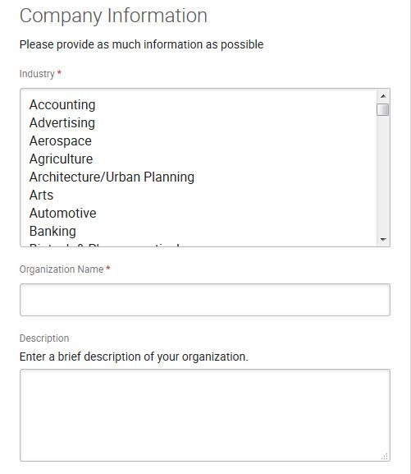
The red star indicates a required field

Once you have completed all the mandatory company information fields and entered as much information as you wish, please check the box stating “I am not a robot” and click “submit” at the bottom of the form. If you are also posting a job, instead of “submit” you will see the word “next”

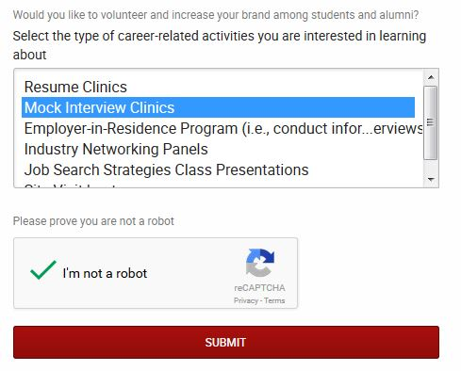

Once you have submitted your registration (and job posting if applicable), please allow 48 hours (or 72 if you register around the dates of our Fall or Spring Career Fairs) to hear back from us. If your registration is approved, you will receive an email from ucc-employerhelp@umd.edu (check your spam/junk mail) with your username and password.

We may also be in contact with you prior to approving your registration to ask for more information. Please be sure to email us back within 3 business days with your response, or the registration will be deleted.

If the job you are looking for is short-term in nature (i.e. babysitting, tutoring etc) then you may wish to use our QuickBucks listserv instead, which goes out every Friday to around 2500 students (you can post a maximum of 4 times on here). You can also use the QuickBucks option if you do not meet one of our recruiting guidelines (i.e. no corporate office address).

Thanks again for your interest in recruiting at UMD. If you have any questions about signing up for Careers4Terps, please email Michael Maiden, the On-Campus Recruitment Coordinator, at mmaiden@umd.edu

